DATA ANALYSIS
Efficiency calculations:
N_ref (120 kev peak) | $$σN_ref$$ | I_ref | $$σI_ref$$
19458.1 | 148.52 | 28.37 | 0.13
33304.5 | 148.52 | 28.37 | 0.13
43399.7 | 227.815 | 28.37 | 0.13

Day 1 and Day 2: |  | Day 3:
N_i | $$σN_i$$ | N_i | $$σN_i$$ | I_i | $$σI_i$$
4754.74 | 84.59 | 6363.96 | 100.319 | 7.53 | 0.04
11587.8 | 115.705 | 15362.8 | 134.584 | 26.57 | 0.11
421.276 | 51.06 | 667.661 | 57.608 | 3.125 | 0.014
910.91 | 63.36 | 845.467 | 67.15 | 12.97 | 0.06
1669.06 | 52.068 | 1938.36 | 58.15 | 14.63 | 0.06
887.99 | 42.45 | 1052.93 | 51.22 | 10.13 | 0.05
1283.13 | 47.27 | 1358.98 | 55.68 | 13.54 | 0.06
1738.67 | 43.16 | 2183.7 | 49.48 | 20.85 | 0.09
Table 1: Intensities and number of counts used for relative efficiency calculations
Europium Efficiencies:
 | Day 1: |  | Day 2: |  | Day 3:
Gamma energy/Channel | Efficiency | $$σEff$$ | Efficiency | $$σEff$$ | Efficiency | $$σEff$$
244.697 kev | 0.557184 | 0.013648 | 0.537883 | 0.0105624 | 0.552465 | 0.0099637
344.279 kev | 0.374191 | 0.006016 | 0.371506 | 0.0046657 | 0.377965 | 0.0045109
443.965 kev | 0.218429 | 0.016414 | 0.114835 | 0.0139472 | 0.139662 | 0.0121059
778.821 kev | 0.0943952 | 0.004872 | 0.059826 | 0.0041880 | 0.042612 | 0.0034031
964.079 kev | 0.0909016 | 0.003942 | 0.0971816 | 0.0031203 | 0.086162 | 0.00269
1085.87 kev | 0.0746734 | 0.004773 | 0.0746715 | 0.0038526 | 0.067946 | 0.0033557
1112.07 kev | 0.0707218 | 0.003900 | 0.0807251 | 0.0030395 | 0.002742 | 0.0027422
1408.01 kev | 0.0702751 | 0.002392 | 0.0710342 | 0.0018465 | 0.001649 | 0.0016497
Table 2: Europium efficiencies

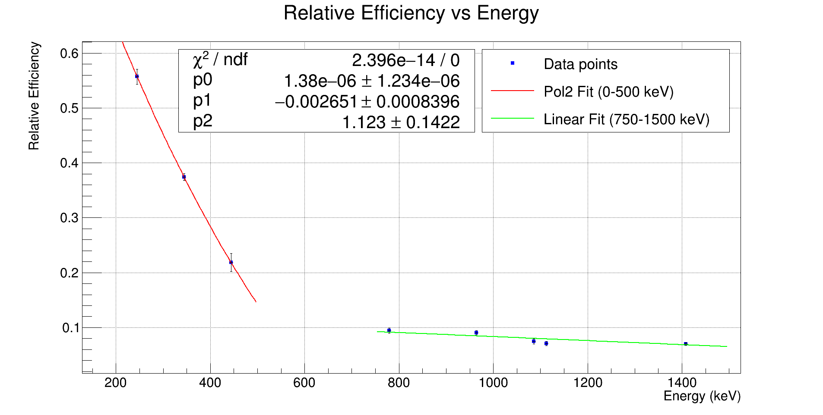
Figure 2: Efficiency fit function Day -1

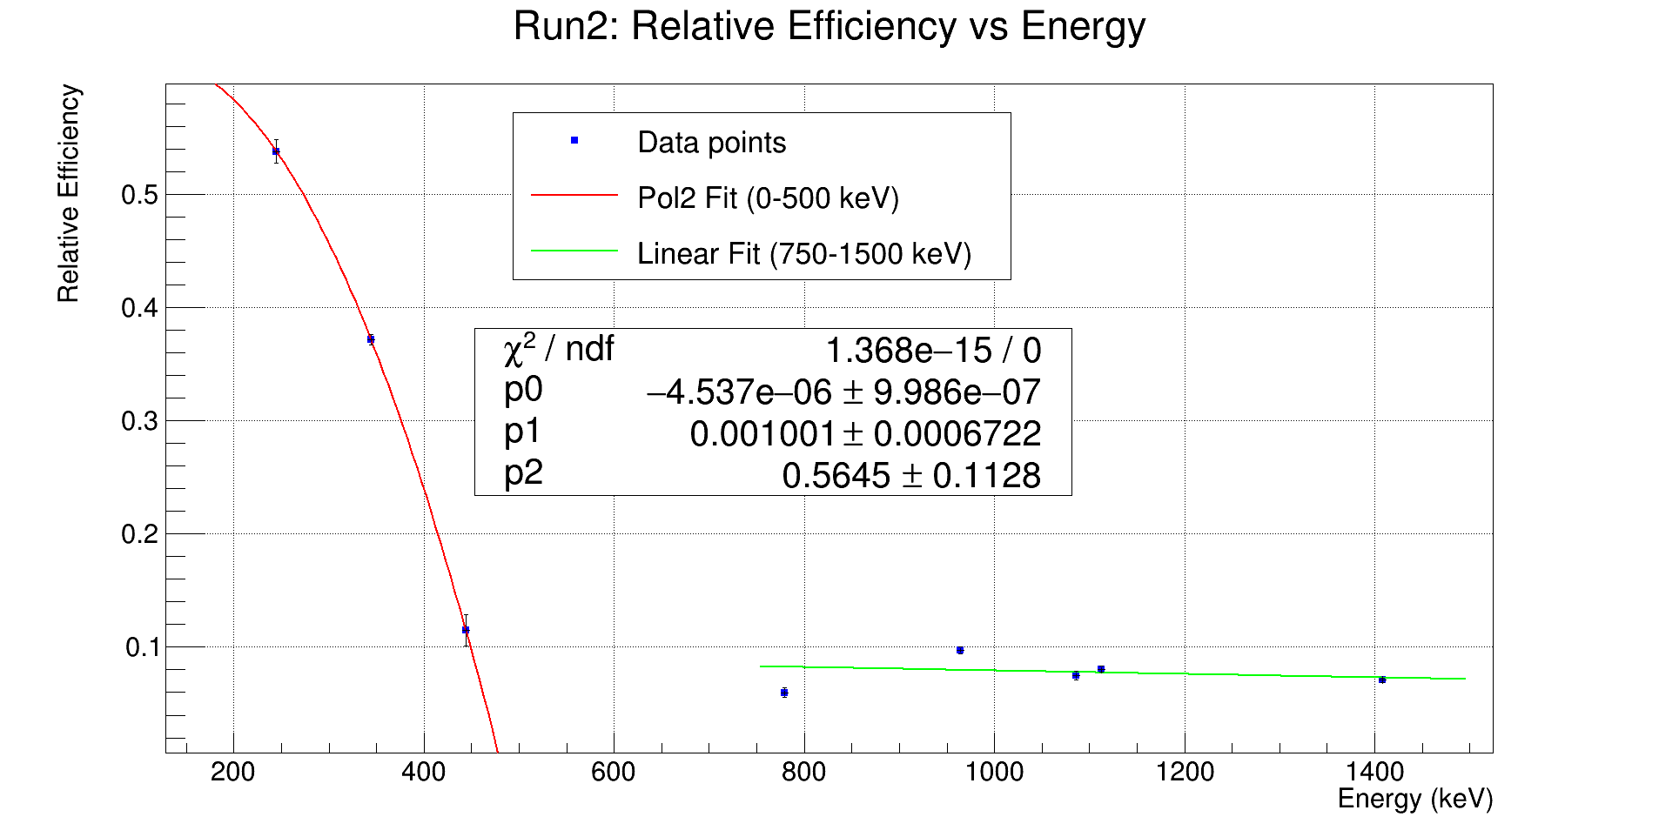
Figure 3: Efficiency fit function - Day 2

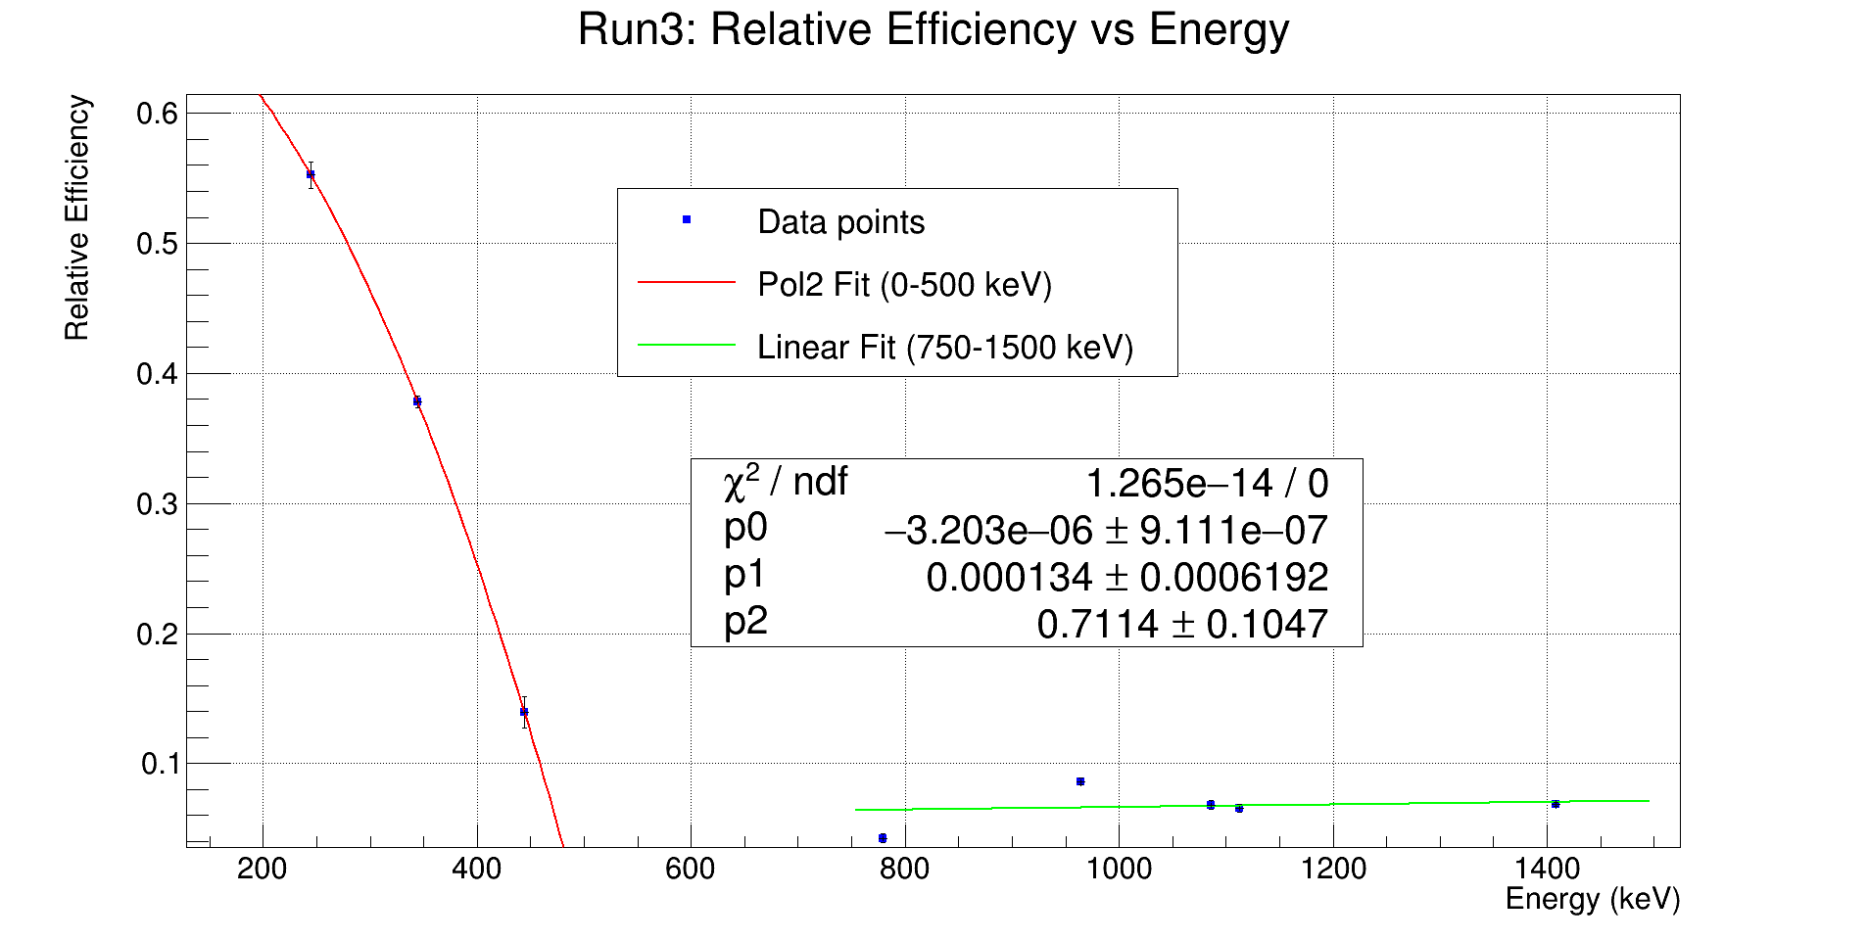
Figure 4: Efficiency fit function - Day 3

 | Run | a | b | c | Energy Ranges
 | Run 1 | 1.38049e-06 +/- 1.23416e-06 | -0.00265069 +/- 0.000839626 | 1.12314 +/- 0.14224 | 0-500 keV
 | Run 1 | -3.66794e-05 +/- 7.15112e-06 | 0.120163 +/- 0.00859698 | N/A | 750-1500 keV
 | Run 2 | -4.5368e-06 +/- 9.98605e-07 | 0.00100131 +/- 0.000672172 | 0.564514 +/- 0.112805 | 0-500 keV
 | Run 2 | -1.52647e-05 +/- 5.75405e-06 | 0.0945574 +/- 0.00697907 | N/A | 750-1500 keV
 | Run 3 | -3.20274e-06 +/- 9.11052e-07 | 0.000134008 +/- 0.000619206 | 0.711443 +/- 0.104704 | 0-500 keV
Figure 4a: Coefficients and parameters for efficiency fit functions.

- $ax^{2}+bx+C$
- $ax + b$
Fig 4b. Fits used for 0-500 kev; 750-1500 kev.

Uranium:

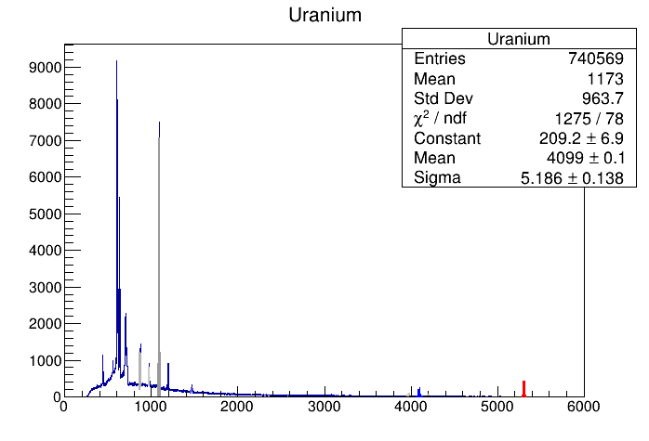
Figure 5. Uranium Sample Spectrum.

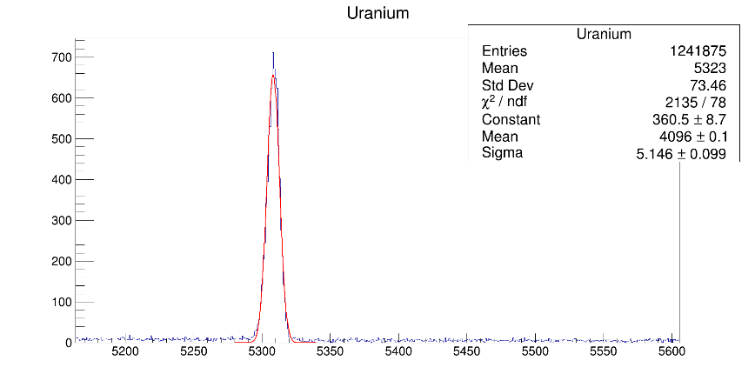
Figure 6. Uranium-238 Peak of 1001 kev gamma.

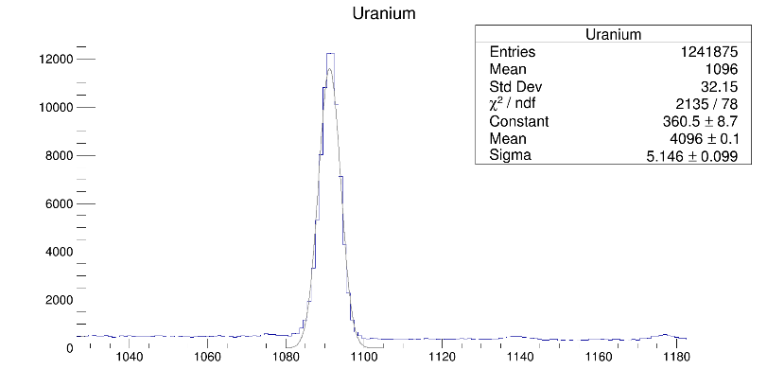
Figure 7. Uranium-235 Peak of 185 kev gamma.

Decay constants:
$$λ_{235}=9.8542*{10}^{-1}$$
$$λ_{238}=1.55101*{10}^{-1}$$

Gamma energies  U-235:  1080-1105  Channel  U-238: 5280- 5340  Channel | Number of counts | Efficiencies | Branching ratios | Decay counts | Number of atoms | Isotopic ratio
Day 1: |  |  |  |  |  | 0.00276725 +/- 0.000047
U-235
185.715 kev | 61583.2 | 0.6784 | 57.2 +/- 0.9 | 1076.63 | 1.09252e12
U-238
1001.7 kev | 51559.6 | 0.0834 | 0.842 +/- 0.008 | 61234.7 | 3.94805e14
Day 2: |  |  |  |  |  | 0.00282513 +/- 0.000030
U-235

185.715 kev | 172023 | 0.593998 | 57.2 +/- 0.9 | 3007.39 | 3.05179e12
U-238
1001.7 kev | 141073 | 0.0792668 | 0.842 +/- 0.008 | 167545 | 1.08023e15
Day 3: |  |  |  |  |  | 0.00242883 +/- 0.000032
U-235 | 112132 | 0.625868 | 57.2 +/- 0.9 | 1960.36 | 1.9893e12
185.715 kev
U-238 | 107404 | 0.0664421 | 0.842 +/- 0.008 | 127558 | 8.22421e14
1001.7 kev
Table 3: Uranium efficiencies and Isotopic abundance

Equations Used for Isotopic and Uncertainty Calculation:

- $number of gammas emitted=\frac{number of gammas in the peak}{efficiency}$

- $number of decays of uranium =\frac{number of gammas emitted}{Relative Intensity}$

- $number of atoms of uranium=\frac{number of decays of uranium}{λ}$
- $λ=\frac{\log_{2}2}{t_{1/2}}$
- $R=\frac{number of atoms of U235}{number of atoms of U238}$

- $Percentage value=\frac{number of atoms of U235}{number of atoms of U235+number of atoms of U238}$

- $σ_{R}=R⋅\sqrt{{\left(\frac{σ_{235}}{N_{235}}\right)}^{2}+{\left(\frac{σ_{238}}{N_{238}}\right)}^{2}}$

Data Analysis Updates and Fixes:
- From the first analysis report the process of how we obtained the isotopic ratio didn’t change. The changes that were applied here were that we used the firestone tables and Nudat, to get the absolute intensities gamma (%) and that helped us to get more correct coefficient parameters and fitting. From there we did Isotopic Comparison for the U-235 185 kev gamma, and the U-238 1001.7 kev gamma and obtained the isotopic ratio that demonstrated that the source was indeed depleted. The error analysis we applied to our values goes like this we took the count uncertainties of the 2 reference peaks we chose made those values go through same isotopic abundance process to get specific number of atoms uncertainty and then applied propagation of error on (equation 7.) from above to get the uncertainty of isotopic ratio measurement.

